**Data Description Report**

**Machine Predictive Maintenance Classification**

**Data Quantity**

* **File Format**
* The given dataset is in CSV file format.
* A CSV file format is a delimited text file that separates values using commas.
* Each line in the file represents a data record, consisting of 10 fields separated by commas.
* **Data** **Gathering**

Since real predictive maintenance datasets are generally difficult to obtain and difficult to publish, we present and provide a synthetic dataset that reflects real predictive maintenance encountered in industry to the best of our knowledge.

We can find source of data from given link :

<https://drive.google.com/file/d/1xFhSYUi938NJa0nqXn3mh5jagn4scJ1o/>

* **Data Dimension**

|  |  |
| --- | --- |
| Fields | 10 |
| Records | 10,000 |

**Data Quality**

* **Characteristics Of Data**

The dataset contains features that are relevant to the business question of predictive maintenance for industrial machines. The features include **air temperature, process temperature, rotational speed, torque, and tool wear**, which are all important indicators of potential machine failure.

* **Data Description & Types**
* UID: A unique identifier ranging from 1 to 10,000.
* productID: A string consisting of a letter L, M, or H for low (50% of all products), medium (30%), and high (20%) as product quality variants and a variant-specific serial number.
* air temperature [K]: Generated using a random walk process later normalized to a standard deviation of 2 K around 300 K.
* process temperature [K]: Generated using a random walk process normalized to a standard deviation of 1 K, added to the air temperature plus 10 K.
* rotational speed [rpm]: Calculated from power of 2860 W, overlaid with a normally distributed noise.
* torque [Nm]: Torque values are normally distributed around 40 Nm with an Ïƒ = 10 Nm and no negative values.
* tool wear [min]: The quality variants H/M/L add 5/3/2 minutes of tool wear to the used tool in the process.
* Failure or Not: A binary label that indicates whether the machine has failed in this particular data point for any of the following failure modes are true.
* Type of Failure: A categorical label that indicates the type of failure, if any.

This dataset contains the **numeric and strings** values.

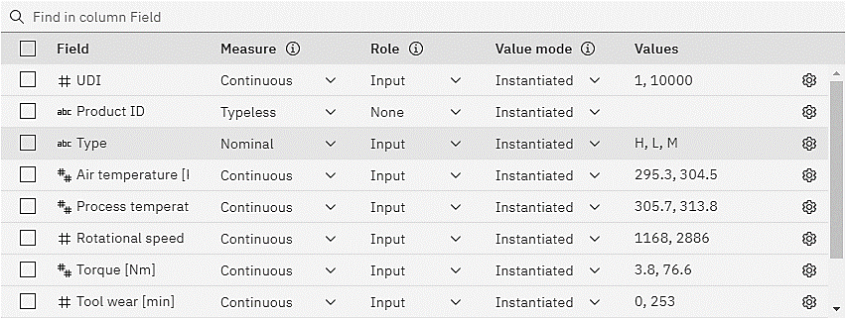



SPSS Modeler: Type Node

|  |  |  |  |  |  |  |  |  |  |
| --- | --- | --- | --- | --- | --- | --- | --- | --- | --- |
| Name | Measurement | Type | Min | Max | Mean | Std. Dev | Skewness | Unique | Valid |
| UDI | Continuous | Long | 1 | 10,000 | 5000.5 | 2886.896 | 0 | 0 | 10000 |
| Product ID | Nominal | String | -- | -- | -- | -- | -- | 255 | 10000 |
| Type | Nominal | String | -- | -- | -- | -- | -- | 3 | 10000 |
| Air temperature | Continuous | Double | 295.30 | 304.50 | 300.005 | 2.000 | 0.114 | 0 | 10000 |
| Process temperature | Continuous | Double | 305.70 | 313.80 | 310.006 | 1.484 | 0.015 | 0 | 10000 |
| Rotational speed | Continuous | Long | 1,168 | 2,886 | 1538.77 | 179.284 | 1.993 | 0 | 10000 |
| Torque | Continuous | Double | 3.800 | 76.600 | 39.987 | 9.969 | -0.010 | 0 | 10000 |
| Tool wear | Continuous | Long | 0 | 253 | 107.951 | 63.654 | 0.027 | 0 | 10000 |
| Target | Continuous | Long | 0 | 1 | 0.034 | 0.181 | 5.150 | 0 | 10000 |
| Failure Type | Nominal | String | -- | -- | -- | -- | -- | 6 | 10000 |

* Data Statistics
* **Key Attributes / Priority Fields**

It could be difficult to prioritize field without any insight knowledge of machine. But we can analyse the below fields for our projects:

* Air temperature
* Process temperature
* Rotational Speed
* Torque
* Tool wear
* **Non-Priority Fields**

There are **UID and Product ID** attributes which would not helping to analyse the feature of machine and patterns. It is only a information to specific record to identify unique transaction.